CC3 - Chapter 8 - Version A Name: ____________________ Date: ____________

1. Solve the equation. Show your work.
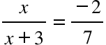

2. Rewrite each expression in a simpler form. Show your work!
a. ${\left(2x^{4}\right)}^{3}$ b. $\left(-3x^{2}y^{-4}\right)\left(2x^{4}y^{2}\right)$ c. $\frac{a^{6}}{a^{3}}$

3. Rewrite the number 3,200,000 in scientific notation.

4. Rewrite the number 2.6 x 10⁻³ in standard form.

5. Lolly rushed inside the moment she got home, clearly very excited. When her mother asked her what was up, Lolly said “I got a great interest rate on my account at the bank!” she replied. “I’m going to figure out how much money I’m going to have if I leave it there for three years.” Then Lolly wrote:
A = 500(1.0325)36
How much money did Lolly put into the bank? What interest rate is Lolly getting? Is it simple interest or compounded? If it is compounded, how many times a year? How much will Lolly have at the end of the three years? Explain all of this clearly and completely.

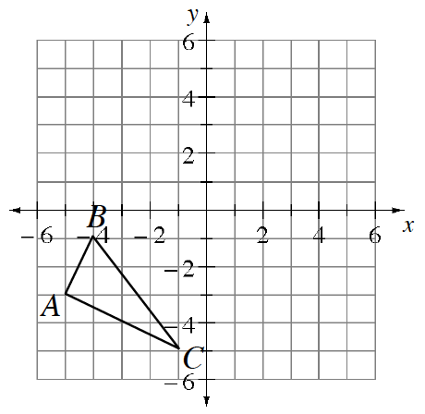
6. On the graph at right, draw two new triangles.
a. The first triangle is ΔABC translated four units right, and one unit down.

b. The second triangle is ΔABC reflected across the x-axis.

